

**UNIVERSITY OF PETROLEUM & ENERGY STUDIES**

**Dehradun**

**CONTINOUS INTEGRATION**

**AND**

**CONTINOUS DELIVERY**

**Lab Viva**

**Name: Shivani Chauhan**

**Course: B. TECH CSE DevOps (2018-22)**

**Roll no.: R171218096**

**SapId: 500068969**

**Lab Viva**

**Step 1- Run Command on command prompt “java –jar Jenkins.war”**

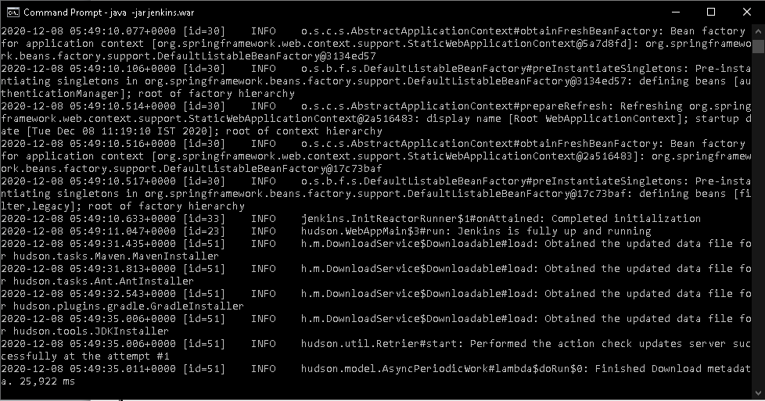

**Step 2- Type “localhost:8080” then Jenkins dashboard will appear.**

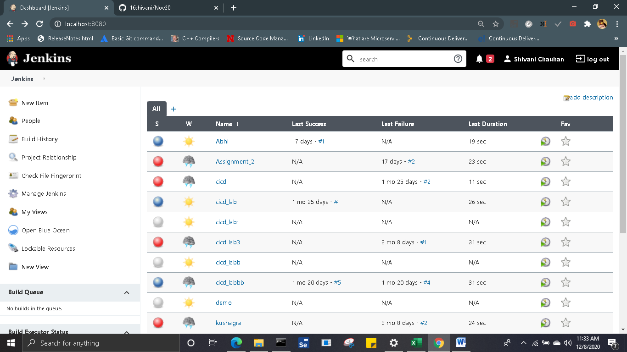

**Step 3- Create a repository on github and add jenkinsfile and other necessary files.**

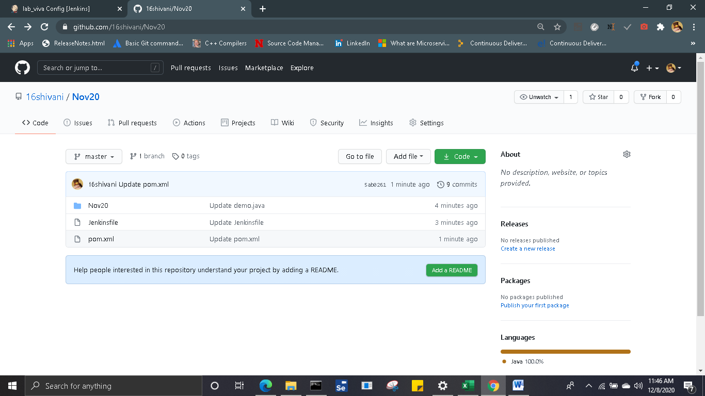

**Step 4- Create a pipeline in Jenkins named “lab_viva” and do the configurations needed like adding the github repository url.**

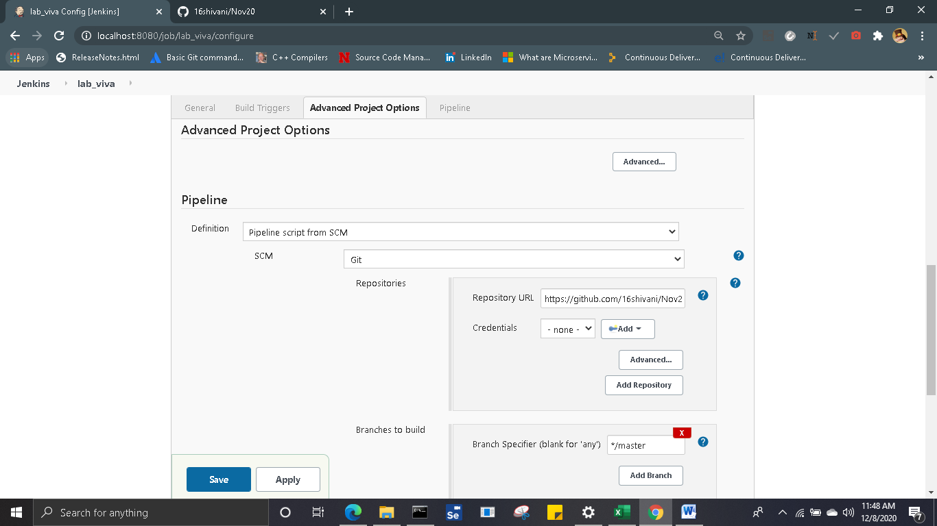

**Step 5- Now build the pipeline**

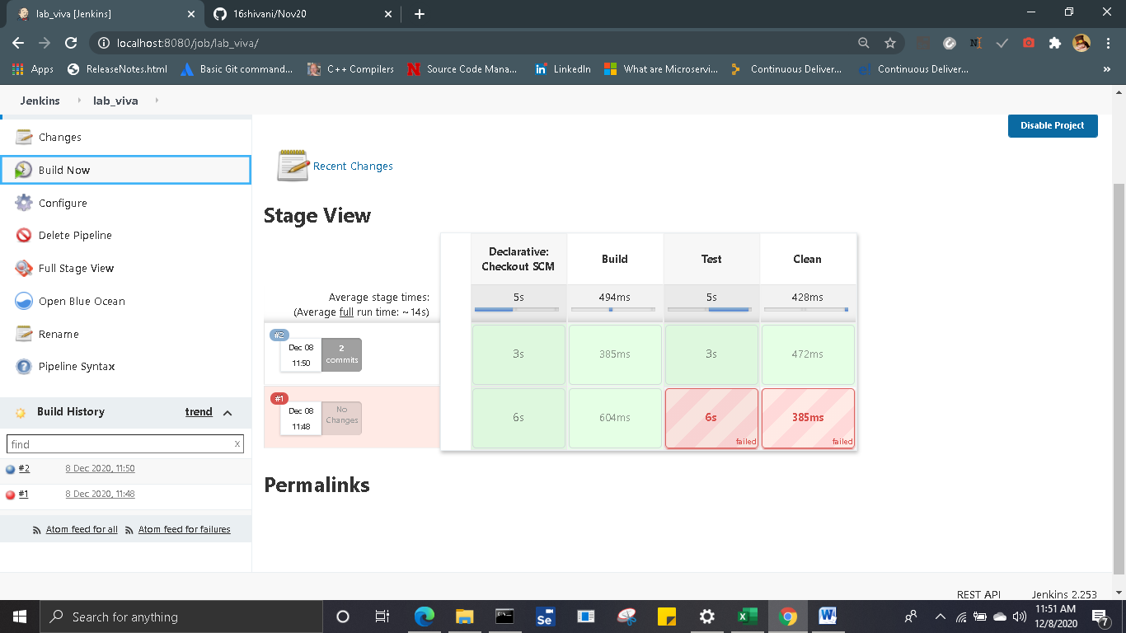

**Console Output:**

